INTRODUCTION TO THE PROJECT

DATA ANALYSIS OF IPL 2025

IPL (INDIAN PREMIER LEAGUE): -
The IPL, or Indian Premier League, is a professional Twenty20 (T20) cricket league in India. It is widely regarded as the most popular and lucrative T20 cricket league in the world.
The Indian Premier League (IPL) is one of the most popular and competitive professional Twenty20 cricket leagues in the world. Since its inception in 2008, the IPL has gained immense popularity, not only for its exciting matches and star-studded teams but also for the rich data it generates. Every match produces detailed statistics about players, teams, scores, and outcomes, making it an ideal subject for data analysis.
The primary objective of this project is to analyze IPL data to uncover insights related to player performances, team strengths, match outcomes, and trends across different seasons. By examining various parameters such as runs scored, wickets taken, strike rates, economy rates, and toss results, this analysis aims to provide a deeper understanding of how teams and players perform under different conditions. This analysis can also help identify patterns that may assist in strategic decision-making for teams or enhance fan engagement by predicting match outcomes.
To perform this analysis, commonly used tools and technologies include Python for data manipulation and analysis, Pandas for handling structured datasets, Matplotlib and Seaborn for data visualization, and optionally Excel, SQL, or Tableau for reporting and interactive dashboards. These tools allow for efficient processing of large datasets and enable clear, visual representation of findings.
The datasets typically used in IPL analysis consist of match-level information (such as dates, venues, teams, scores, and winners), player statistics (like runs, balls faced, wickets, and strike rates), and team statistics (overall wins, losses, and seasonal performance). Using this data, analysts can uncover trends, compare performances, and even build predictive models to forecast future outcomes.
Overall, this project on Data Analysis of IPL is valuable for both academic and professional purposes. It helps develop practical skills in data handling, visualization, and statistical analysis while offering meaningful insights into cricket performance. By understanding patterns in IPL data, teams, analysts, and fans can make informed decisions, enhancing the overall experience of the sport.

Here are its key characteristics:
- Format: It's a franchise-based model, similar to major sports leagues like the NBA or NFL. Teams represent different Indian cities and are owned by a mix of corporations and celebrities.
- Player Acquisition: Teams build their squads through an annual auction, where they bid for players from around the world. This creates a unique mix of international stars and talented Indian players on the same team.
- The Game: It's played in the fast-paced T20 format, where each team faces a maximum of 20 overs (120 balls). This makes the game highly explosive, focused on big hits and exciting finishes, usually lasting about 3 hours.
- Season: The tournament typically runs from March to May every year.
- Global Appeal: The IPL is a massive sporting spectacle, known for its:
  - High Salaries: Top players earn millions of dollars.
  - Star Power: Features the best cricketers from India, Australia, England, South Africa, etc.
  - Entertainment: It blends high-octane cricket with Bollywood-style glamour, cheerleaders, and intense fan engagement.
(In short, the IPL is more than just cricket; it's a global sporting and entertainment phenomenon)
1. Concept and Foundation
- Founding Body: The IPL was founded by the Board of Control for Cricket in India (BCCI) in 2007.
- Inaugural Season: The first season was held in 2008.
- Format Inspiration: It successfully adapted the franchise-based model from major global sports leagues like the NBA (USA) and the English Premier League (Football) to cricket.
2. Core Structure and Format
- Tournament Type: Franchise-Based T20 Cricket.
- Teams: The league currently consists of 10 teams, each representing a different major Indian city or state (e.g., Mumbai Indians, Chennai Super Kings).
- Team Ownership: Franchises are owned by a mix of large Indian corporations, business tycoons, and global celebrities (from Bollywood and other industries).
- Player Acquisition: Teams are built through a player auction held periodically (usually a mega-auction every 3 years and a mini-auction in between). Teams bid for players in a public auction, creating a unique and exciting team-building process.
- Tournament Structure:

  - League Stage: A double round-robin format where each team plays every other team twice (home and away).
  - Playoffs: The top four teams from the league stage qualify for the playoffs, which consist of:

- Qualifier 1: 1st vs 2nd rank (winner goes to final).
- Eliminator: 3rd vs 4th rank (loser is knocked out).
- Qualifier 2: Winner of Eliminator vs Loser of Qualifier 1.

  - The Final: Winner of Qualifier 1 vs Winner of Qualifier 2.
3. The Game: T20 Cricket
- Match Duration: Each team bats for a maximum of 20 overs (120 balls). A full match typically lasts about 3-4 hours.
- Pace and Excitement: The shortened format encourages aggressive, fast-paced play, prioritizing big hits (fours and sixes), quick running, and attacking bowling. This makes it highly accessible and entertaining for a global audience.
4. Key Features and Global Appeal
- Global Star Power: The IPL attracts the very best international cricket stars (from Australia, England, South Africa, West Indies, etc.) to play alongside and against the top Indian players.
- Massive Financial Scale:
  - Player Salaries: Top players command salaries in the multi-million-dollar range.
- Entertainment Extravaganza: It is more than just cricket. It features:
  - Opening and closing ceremonies with Bollywood and music performances.
  - Team cheerleaders and mascots.
- Platform for Young Talent: The IPL provides a massive platform for young, uncapped Indian players to showcase their skills on a world stage, often fast-tracking their entry into the national team.
- Fan Engagement: It has a massive and passionate fan base, with intense rivalries between teams, much like in European football.
5. Season and Timing
- The IPL is an annual event typically held over two months, from March/April to May, before the monsoon season in India.
6. Governing Body and Rules
- Governing Body: The BCCI oversees the entire league.
- Innovative Rules: The IPL has introduced several rules to increase excitement, such as the Decision Review System (DRS), the Impact Player rule (allowing a straight substitution), and strategic timeouts.

OBJECTIVE TO THE PROJECT

OBJECTIVES OF STUDY

The Indian Premier League (IPL) is not just a cricket tournament; it's a massive data-generating ecosystem. Data analysis has become a cornerstone of the IPL, transforming how teams, broadcasters, and fans interact with the sport. The primary objectives of this analysis are multifaceted and aim to drive strategic advantages and deeper engagement.
The main objectives of this project are as follows:
- To collect and understand the IPL 2025 dataset for analysis and research purposes.
- To clean, preprocess, and organize the raw data for accurate and efficient analysis.
- To analyze team and player performance using statistical and data analytics methods.
- To apply Python libraries such as Pandas, NumPy, and Matplotlib for data handling and visualization.
- To identify match-wise trends, patterns, and performance indicators throughout the IPL 2025 season.
- To evaluate the impact of individual player contributions on team results.
- To use data visualization techniques to present insights clearly through graphs and charts.
- To compare the performance of different teams based on key performance metrics.
- To demonstrate the practical application of data science techniques in the field of sports analytics.
- To interpret the results and derive meaningful conclusions that support decision-making in cricket analysis.
For Teams and Franchises:
Enhancing Performance and Strategy
- Player Acquisition and Valuation: To scientifically identify and value players at auctions by analysing their past performance (e.g., batting strike rates, bowling economies, performance under pressure) rather than relying solely on reputation.
- Tactical Decision-Making: To formulate data-driven strategies for specific opponents, such as deciding batting orders, bowling changes, and field placements based on historical match-ups (e.g., a specific bowler's record against a particular batsman).
- Opposition Analysis: To deconstruct the strengths and weaknesses of opposing teams, identifying key players to target and potential gaps in their lineup.
- In-Game Optimization: To make real-time decisions, like calculating the ideal score to defend or the required run rate, and assessing the impact of the Decision Review System (DRS) using ball-tracking data.
For Broadcasters and Media:
Enriching Viewer Experience
- Engaging Commentary and Graphics: To provide viewers with insightful statistics, visualizations (like win probability graphs, wagon wheels, and pitch maps), and predictive analysis that make the broadcast more informative and engaging.
- Content Creation: To generate compelling narratives and storylines around player milestones, team rivalries, and record-breaking performances, keeping fans invested throughout the season.
For Fans and Fantasy League Players
- Informed Engagement: To empower fans with statistics to better understand the game, debate player performances, and make informed choices for their fantasy league teams.
- Predictive Analysis: To allow fans to engage in predicting match outcomes, top performers, and tournament winners based on data trends.
For League Management and Sponsors
- Business Intelligence: To analyze viewership trends, ticket sales, and merchandise popularity to optimize scheduling, pricing, and marketing campaigns.
- Maximizing Commercial Value: To help sponsors identify the most valuable teams and players for brand associations by analysing player influence and audience reach.

PROJECT OVERVIEW

DATA ANALYSIS OF IPL
Comprehensive Performance and Strategic Analysis of the Indian Premier League (IPL).
Project Objective
The primary objective of this data analysis project is to extract meaningful insights from historical IPL data to understand team performance, player valuation, and match dynamics. The project aims to move beyond basic statistics and uncover strategic patterns that can influence decision-making for franchises, enhance fan engagement, and provide a deeper analytical understanding of the tournament.
Key Questions (Problem Statement)
This analysis seeks to answer critical questions such as:
- Which teams and players have been the most successful in IPL history?
- What factors most strongly correlate with a team's victory?
- How can player performance be objectively valued for auctions?
- What are the winning trends (e.g., toss decision, home advantage)?
- How have team and player performances evolved over the seasons?
Data Sources
The analysis will be conducted using structured datasets, typically comprising:
- Matches Data: Contains records of every match played (season, venue, teams, winner, toss decision, etc.).
- Deliveries Data: A ball-by-ball dataset detailing each delivery (batsman, bowler, runs, wickets, extras, etc.).
- Player Data: Background information of all players.
- Auction Data: Historical player auction prices (if available).
Methodology & Approach
The project will follow a structured data analysis lifecycle:
Step 1: Data Acquisition & Collection
- Sourcing reliable IPL datasets (e.g., from public repositories like Kaggle).
Step 2: Data Cleaning & Preprocessing
- Handling missing values, correcting data entry errors, and standardizing team names (e.g., "Delhi Daredevils" vs "Delhi Capitals").
- Structuring the data for efficient analysis.
Step 3: Exploratory Data Analysis (EDA)
- Performing unique-variate and bi-variate analysis to identify patterns, trends, and anomalies.
- Using visualizations (bar charts, pie charts, histograms) to understand the distribution and relationship between variables.
Step 4: Feature Engineering
- Creating new, meaningful metrics from existing data, such as:
- Player Impact Score: A composite metric of batting and bowling performance.
- Season-wise Consistency: Measuring a player's performance stability.
- Batsman Strike Rate and Bowling Economy in different match phases (Powerplay, Death Overs).
Step 5: In-depth Analysis & Visualization
- Team Performance: Analyzing wins/losses, home vs. away records, and performance over seasons.
- Player Performance: Identifying most valuable players (MVPs), top batsmen, bowlers, and all-rounders.
- Match Dynamics: Analyzing the impact of the toss, venue-specific strategies, and success run-rates.
Step 6: Deriving Insights & Reporting
- Synthesizing the findings into actionable insights and strategic recommendations.
- Creating a final report and dashboard summarizing the key outcomes.
Expected Outcomes & Deliverables
- An Interactive Dashboard: A visual tool (e.g., using Tableau or Power BI) to explore team and player stats.
- Comprehensive Report: A detailed document with findings, charts, and strategic recommendations.
- Player Valuation Model: A data-driven framework to suggest a player's worth in auctions.
Tools and Technologies
- Programming Language: Python (with libraries like Pandas, NumPy, Matplotlib, Seaborn) or R.
- Data Visualization: Tableau, Power BI, or Plotly for creating interactive dashboards.
- Environment: Jupiter Notebook for analysis and scripting.
Conclusion
This project demonstrates the power of data analytics in decoding the complexities of a sport like cricket. By systematically analysing IPL data, we can transition from anecdotal evidence to evidence-based conclusions, providing valuable intelligence for teams, a richer narrative for broadcasters, and a more profound understanding for fans.

TECHNOLOGY USED IN PROJECT

INTRODUCTION TO PYTHON

Python is a computer programming language often used to build websites and software, automate tasks, and analyze data. Python is a general-purpose language, not specialized for any specific problems, and used to create various programmers. This versatility and its beginner-friendliness have made it one of the most used programming languages today. In 2020, more than one-third of Indian IT professionals said Python was their preferred programming language. It continues to top lists of the most desired programming languages in the country.
Python is commonly used for developing websites and software, task automation, data analysis, and data visualization. Since it’s relatively easy to learn, Python has been adopted by many non-programmers, such as accountants and scientists, for a variety of everyday tasks, like organizing finances.
"Writing programs is a very creative and rewarding activity," says University of Michigan and Coursera instructor Charles R Severance in his book Python for Everybody. "You can write programs for many reasons, ranging from making your living to solving a difficult data analysis problem to having fun to helping someone else solve a problem."
What can you do with Python?
Some things include:
- Data analysis and machine learning
- Web development
- Automation or scripting
- Software testing and prototyping
- Everyday tasks
Python has become a staple in data science, allowing data analysts and other professionals to use the language to conduct complex statistical calculations, create data visualizations, build machine learning algorithms, manipulate and analyze data, and complete other data- related tasks. Python can build various data visualizations, like line and bar graphs, pie charts, histograms, and 3D plots. Python also has many libraries that enable coders to write programs for data analysis and machine learning more quickly and efficiently, like TensorFlow.
Why Do Data Analysts Prefer Using Python?
The highly cross-functional language offers several perks to its users. It helps data analysts to make sense of complicated data sets and make them easier to understand.
Another pro of using Python is its high readability. Python code is easier for collaborating with other analysts, for communicating with other technical stakeholders, and it makes it more maintainable when it comes time to adapt it for new data sources and needs
The language fits well for data analyst professionals as it provides heavy support and offers an extensive range of libraries for several tasks.
Python is known for its simple syntax and readability, which is a major benefit. It cuts down the time data analysts otherwise spend familiarizing themselves with a programming language The
STRENGTHS AND WEAKNESSES OF PYTHON
Python is the language that is used by big brands in the whole world. Its demand is increasing day by day. Python is used by Google, Yahoo, Intel, IBM, Cisco, HP, NASA and many more big names in the list. Here we will discuss the various strengths and weaknesses of python.
Strengths of Python
1. Easy to Learn: Python is very easy to learn and it does not have any complex syntax and rules as followed by another language. You can learn Python very easily if you don't have any coding experience. You can say it is very user-friendly.
2. Free to Use: Python is free to use and available to download from its official website. You can download Python by clicking on the link given here (Download Python). The source code of Python is available for the public under GPL(General Purpose License) in which you can download it, modify it, use it, distribute it. You are totally free to do whatever you want to do with python.
3. Portable: Portability is the main strength of python. Users can run python programs on various platforms. Suppose you wrote a program in windows and now you want to run this program on Linux or Mac Operating system, You can easily run your programs on (Windows, Mac, Linux, Raspberry Pi, etc). You can say Python is a platform-independent programming language.
4. Interpreted: Python is interpreted language which means it does not require any kind of compiler to run the program. Python converts its code into bytecode which gives instant results. Python is interpreted means that its code is executed line by line which makes it easier to debug.
5. Extensible: It is a very major strength of Python. First, understand the meaning of extensible in Python that it is developed in a way that allows the addition of new capabilities and functionality. it does let you interface Python with libraries written in other languages. (mainly C or C++, but using C as a bridge you can call other languages as well that provide C interfaces.)
6. Extensive Libraries: When you download Python it comes with a large number of libraries that can be used for a specific purpose. You can download additional libraries according to your need or project demands. With the help of these libraries, you don't need to write the complete code just use these libraries and job done with a small number of instructions. Python provides libraries for web browsers, image manipulation, databases, email and for many other purposes.
7. Embeddable: One of the best features of Python is that it is also embeddable. For example, you can embed YouTube video code into your HTML code. Similarly, you can embed Python code in other programming language like C++. With this feature, Python gives you the power to add its code like as a script in your code in a different language.
8. Object-Oriented: Python can be used as an object-oriented language in which data structure and functions are combined in a single unit. Python supports both object-oriented and procedure-oriented approach in the development. The object-oriented approach deals with the interaction between the objects on the other hand procedure-oriented approach deals with functions only.
9. GUI Programming: Python provides many solutions to develop a Graphical User Interface (GUI). Python shipped with a toolkit named tkinter which is widely used for GUI developments. By using Python with tkinter you can create GUI applications very fast and easy.
10. Database Connectivity: Python supports all the database required for the development of various projects. Programmers can pick the best suitable database for their projects. Some examples of database which is supported by python are MySQL, PostgreSQL, Microsoft SQL Server, Informix, Interbase, Oracle and etc.
Weaknesses of Python
Every language has its own limitations. Programmers must know these before starting any new project. We have explained all the good things available in python now the time is to discuss the weaknesses of python.
1. Speed: Python is interpreted and execute code line by line which keeps it slower as compared to C or C++. If speed is not the major concern in the project then you are welcome to use Python.
2. Weak for Mobile Development: Python is the best language for server-side coding. But when we talk in terms of mobile development Python is not very good. This is the major reason that you will rarely see mobile applications developed using Python.
3. Memory Consumption: Python has a very flexible structure for data. If you have a memory limitation in your project then Python may not be a good idea to use. Memory consumption is on the higher side.
4. Database Access Layer Issues: Python has issues with database access layers which restricts it to use in a big company.
5. Run-Time Errors: Python may give you run time errors which lead to disappointment at the end. Python is dynamically typed language and you don't need to mention data type in programs which may end up with run time errors.

PYTHON DATA TYPES

In Python, a data type defines the kind of value a variable can hold. It determines how the data is stored, how it can be manipulated, and the operations that can be performed on it. Python is a dynamically-typed language, meaning you don’t need to declare the data type of a variable explicitly; the interpreter automatically determines the type based on the value assigned to it.

Here's an explanation of the key data types you mentioned:
Numeric Data Types:
Numeric types are used to represent numbers. There are four main numeric types in Python:
- Integer (int): An integer is a whole number, positive or negative, without decimals.
  - x = 5 # integer
  - y = -42 # negative integer
- Floating-Point (float): A floating-point number is a number that has a decimal point (i.e., it represents real numbers).
  - x = 3.14 # float
  - y = -0.5 # negative float
- Boolean (bool): A Boolean represents one of two values: True or False. It's often used for conditional checks and logical operations.
  - x = True # Boolean True
  - y = False # Boolean False
- Complex Number (complex): A complex number consists of a real part and an imaginary part. The imaginary part is denoted by a j or J in Python.
  - x = 3 + 4j # complex number with real part 3 and imaginary part
  - 4 y = -2 + 5j # complex number

Set:
A set is an unordered collection of unique elements. Sets do not allow duplicates and are typically used to store distinct items.
- Unordered: No guaranteed order of elements.
- No duplicates: Each element can appear only once.
- Mutable: Elements can be added or removed.
- my set = {1, 2, 3, 4, 5}

Dictionary:
A dictionary is an unordered collection of key-value pairs. Each key is unique, and each key maps to a value. Dictionaries are defined with curly braces {}.
- Keys must be immutable types (like int, float, str).
- Values can be of any type.
- Keys are unique; duplicates are not allowed.
- my_dict = { 'name': 'Alice', 'age': 25, 'city': 'New York' }
Sequence Data Types:
A sequence is a collection of items ordered by their position. The main sequence types in Python are list, tuple, and string.
- List: A list is an ordered, mutable (changeable), and potentially heterogeneous collection of elements. Lists are defined with square brackets [].
  - my list = [1, 2, 3, 'apple', 4.5]
- ​Tuple: A tuple is similar to a list, but it is immutable, meaning that once a tuple is created, its elements cannot be changed. Tuples are defined with parentheses ().
  - my tuple = (1, 2, 3, 'apple', 4.5)
- String: A string is a sequence of characters (text) enclosed in single (') or double (") quotes. Strings are immutable, like tuples.
  - my_string = "Hello, world!"

INTRODUCTION TO DATA ANALYTICS

Data analysis is the process of inspecting, cleaning, transforming, and modeling data to extract useful information, make conclusions, and support decision-making. The primary goal is to find patterns, trends, correlations, and insights within data to help answer questions or make predictions. Analyzing data typically moves through five iterative phases:
- Identify the data you want to analyze
- Collect the data
- Clean the data in preparation for analysis
- Analyze the data
- Interpret the results of the analysis
Data analysis can take different forms, depending on the question you’re trying to answer. Briefly, descriptive analysis tells us what happened; diagnostic analysis tells us why it happened; predictive analytics forms projections about the future; and prescriptive analysis creates actionable advice on what actions to take.
Data Analysts play a crucial role in extracting valuable insights from large volumes of data, helping businesses make informed decisions and drive growth. India has witness EDA significant surge in demand for Data Analysts in recent years, reflecting the growing importance of data- driven decision-making across sectors. This profession combines statistical and analytical skills with a deep understanding of data manipulation and visualization techniques.

THE DATA ANALYSIS PROCESS: A STEP-BY-STEP GUIDE

The process of data analysis is a systematic approach that involves several stages, each crucial to ensuring the accuracy and usefulness of the results. Here, we'll walk you through each step, from defining objectives to data storytelling. You can learn more about how businesses analyze data in a separate guide.
Step 1: Defining objectives and questions
The first step in the data analysis process is to define the objectives and formulate clear, specific questions that your analysis aims to answer. This step is crucial as it sets the direction for the entire process. It involves understanding the problem or situation at hand, identifying the data needed to address it, and defining the metrics or indicators to measure the outcomes.
Step 2: Data collection
Once the objectives and questions are defined, the next step is to collect the relevant data. This can be done through various methods such as surveys, interviews, observations, or extracting from existing databases. The data collected can be quantitative (numerical) or qualitative (non- numerical), depending on the nature of the problem and the questions being asked.
Step 3: Data cleaning
Data cleaning, also known as data cleansing, is a critical step in the data analysis process. It involves checking the data for errors and inconsistencies, and correcting or removing them. This step ensures the quality and reliability of the data, which is crucial for obtaining accurate and meaningful results from the analysis.
Step 4: Data analysis
Once the data is cleaned, it's time for the actual analysis. This involves applying statistical or mathematical techniques to the data to discover patterns, relationships, or trends. There are various tools and software available for this purpose, such as Python, R, Excel, and specialized software like SPSS and SAS.
Step 5: Data interpretation and visualization
After the data is analyzed, the next step is to interpret the results and visualize them in away that is easy to understand. This could involve creating charts, graphs, or other visual representations of the data. Data visualization helps to make complex data more understandable and provides a clear picture of the findings.
Step 6: Data storytelling
The final step in the data analysis process is data storytelling. This involves presenting the findings of the analysis in a narrative form that is engaging and easy to understand. Data storytelling is crucial for communicating the results to non-technical audiences and for making data-driven decisions

TYPES OF DATA ANALYSIS
Data analysis can be categorized into four main types, each serving a unique purpose and providing different insights. These are descriptive, diagnostic, predictive, and prescriptive analyses.
- Descriptive analysis
Descriptive analysis, as the name suggests, describes or summarizes raw data and makes it interpretable. It involves analyzing historical data to understand what has happened inthe past. This type of analysis is used to identify patterns and trends over time. For example, a business might use descriptive analysis to understand the average monthly sales for the past year.

- Diagnostic analysis
Diagnostic analysis goes a step further than descriptive analysis by determining why something happened. It involves more detailed data exploration and comparing different data sets to understand the cause of a particular outcome. For instance, if a company's sales dropped in a particular month, diagnostic analysis could be used to find out why

- Predictive analysis
Predictive analysis uses statistical models and forecasting techniques to understand the future. It involves using data from the past to predict what could happen in the future. This type of analysis is often used in risk assessment, marketing, and sales forecasting. For example, a company might use predictive analysis to forecast the next quarter's sales based on historical data.

- Prescriptive analysis
Prescriptive analysis is the most advanced type of data analysis. It not only predicts future outcomes but also suggests actions to benefit from these predictions. It uses sophisticated tools and technologies like machine learning and artificial intelligence to recommend decisions. For example, a prescriptive analysis might suggest the best marketing strategies to increase future sales.

- Data Analysis Techniques
There are numerous techniques used in data analysis, each with its unique purpose and application. Here, we will discuss some of the most commonly used techniques, including exploratory analysis, regression analysis, Monte Carlo simulation, factor analysis, cohort analysis, cluster analysis, time series analysis, and sentiment analysis.

- Exploratory analysis
Exploratory analysis is used to understand the main characteristics of a data set. It is often used at the beginning of a data analysis process to summarize the main aspects of the data, check for missing data, and test assumptions. This technique involves visual methods such as scatter plots, histograms, and box plots. You can learn more about exploratory data analysis with our course, covering how to explore, visualize, and extract insights from data using Python.

- Regression analysis
Regression analysis is a statistical method used to understand the relationship between a dependent variable and one or more independent variables. It is commonly used for forecasting, time series modeling, and finding the causal effect relationships between variables.

- Factor analysis
Factor analysis is a technique used to reduce a large number of variables into fewer factors. The factors are constructed in such a way that they capture the maximum possible information from the original variables. This technique is often used in market research, customer segmentation, and image recognition.

- Monte Carlo simulation
Monte Carlo simulation is a technique that uses probability distributions and random sampling to estimate numerical results. It is often used in risk analysis and decision- making where there is significant uncertainty.

- Cluster analysis
Cluster analysis is a technique used to group a set of objects in such a way that objects in the same group (called a cluster) are more similar to each other than to those in other groups. It is often used in market segmentation, image segmentation, and recommendation systems.

- Cohort analysis
Cohort analysis is a subset of behavioral analytics that takes data from a given dataset and groups it into related groups for analysis. These related groups, or cohorts, usually share common characteristics within a defined time span. This technique is often used inmarketing, user engagement, and customer lifecycle analysis.

- Time series analysis
Time series analysis is a statistical technique that deals with time series data, or trend analysis. It is used to analyze the sequence of data points to extract meaningful statistics and other characteristics of the data. This technique is often used in sales forecasting, economic forecasting, and weather forecasting.

DATA ANALYST TASKS AND RESPONSIBILITIES
A data analyst is a person who gathers and interprets data to solve a specific problem. The role includes plenty of time spent with data but entails communicating findings too.
Here’s what many data analysts do on day-to-day basis:
- Gather data: Analysts often collect data themselves. This could include conducting surveys, tracking visitor characteristics on a company website, or buying data sets from data collection specialists.

- Clean data: Raw data might contain duplicates, errors, or outliers. Cleaning the data means maintaining the data quality in a spreadsheet or through a programming language so that your interpretations won’t be wrong or skewed

- Model data: This entails creating and designing the structures of a database. You might choose what data types to store and collect, establish how data categories are related, and work through how the data appears.

- Interpret data: Interpreting data will involve finding patterns or trends in data that can help you answer the question at hand.

- Present: Communicating the results of your findings will be a crucial part of your job. You create visualizations like charts and graphs, write reports, and present information to interested parties
Data Analyst roles and responsibilities include -
- To work in collaboration with IT, management and/or data scientist teams to determine organizational goals.
- To dig data from primary and secondary sources.
- To clean the data and discard irrelevant information.
- To perform data analysis and interpret results using standard statistical methodologies.
- To highlight changing trends, correlations and patterns in complicated data sets.
- To create data dashboards, graphs and visualizations.
- To ensure clear data visualizations for management.
- To design, create and maintain relevant and useful databases and data systems.
- To identify trends and make forecast.
EXPLORATORY DATA ANALYSIS
Exploratory data analysis (EDA) is used by data scientists to analyze and investigate data sets and summarize their main characteristics, often employing data visualization methods.
EDA helps determine how best to manipulate data sources to get the answers you need, making it easier for data scientists to discover patterns, spot anomalies, test a hypothesis,or check assumptions.
EDA is primarily used to see what data can reveal beyond the formal modeling or hypothesis testing task and provides a provides a better understanding of data setvariables and the relationships between them. It can also help determine if the statistical techniques you are considering for data analysis are appropriate. Originally developed byAmerican mathematician John Tukey in the 1970s, EDA techniques continue to be a widely used method in the data discovery process today.

Why is exploratory data analysis important in data science?

The main purpose of EDA is to help look at data before making any assumptions. It can help identify obvious errors, as well as better understand patterns within the data, detect outliers or anomalous events, find interesting relations among the variables.
Data scientists can use exploratory analysis to ensure the results they produce are valid and applicable to any desired business outcomes and goals. EDA also helps stake holders by confirming they are asking the right questions. EDA can help answer questions about standard deviations, categorical variables, and confidence intervals. Once EDA is complete and insights are drawn, its features can then be used for more sophisticated data analysis or modeling, including machine.

EXPLORATORY DATA ANALYSIS TOOLS
Here’s an overview of popular tools for Exploratory Data Analysis (EDA), each with unique strengths for data cleaning, visualization, and analysis:
1. Python-Based Tools
  - Pandas
  - Primary data manipulation library for Python, ideal for handling structured data.
  - Enables data cleaning, filtering, and quick statistical summaries with simple functions.
  - Matplotlib
  - Core plotting library for creating static, interactive, and animated visualizations in python.
  - Essential for basic EDA visualizations like histograms, scatter plots, and bar charts.
  - Seaborn
  - Built on top of Matplotlib with a focus on statistical visualization.
  - Useful for quick and advanced visualizations like pair plots, heatmaps, and distribution plots.
  - Plotly
  - Offers interactive visualization capabilities for a richer analysis experience.
  - Supports diverse plot types and geographical visualizations, making it versatile for EDA.
- Sweet viz and Pandas Profiling
- Generate automatic EDA reports with summaries, visualizations, and insights in a single output.
- Useful for obtaining a high-level overview of data characteristics quickly.
- SciPy
- Complements Pandas for advanced statistical analysis and data manipulation.
- • Used for calculating statistical metrics, such as correlation, regression, and hypothesis testing.
- GeoPandas
- Extension of Pandas for geospatial data, facilitating mapping and geographical analysis.
- Ideal for analysing datasets with geographic attributes, like world population distribution.
2. R-Based Tools
  - ggplot2
  - Grammar of graphics library for creating sophisticated plots in R, known for its customization and aesthetics.
  - Often used in EDA for creating complex visualizations, including statistical and spatial
- Data visualizations.
- Data Explorer
- Automates much of the EDA process in R, offering quick data summaries, visualizations,
- and report generation.
- Provides quick insights with minimal code, ideal for early data exploration.
- dplyr and tidyr
- Core libraries in R for data manipulation and cleaning, respectively.
- Allow streamlined operations on data frames, useful for transforming, summarizing, and organizing data.
3. No-Code/Low-Code EDA Tools
- Tableau
- Powerful data visualization and BI tool with drag-and-drop functionality for non programmers.
- Excellent for creating dashboards, exploring data interactively, and spotting patterns.
- Power BI
- Similar to Tableau, offering robust data connectivity and visualization options.
- Often integrated into Microsoft ecosystems, making it popular for corporate EDA.
4. SQL-Based Tools
- SQL and SQL Extensions (e.g., Big Query, Snowflake)
- Enable querying and analysing structured data stored in databases.
- Especially useful for EDA on large datasets stored in cloud databases.
- Mode Analytics
- Combines SQL querying with data visualization for more in-depth analysis.
- Allows data analysts to query data directly from databases and create visualizations in one platform.
5. Spreadsheet-Based Tools
- Microsoft Excel
- Popular for small-to-medium data analysis with pivot tables, charts, and statistical tools.
- Often used for quick, ad-hoc EDA tasks due to its simplicity and accessibility.
- Google Sheets
- Similar to Excel, with collaborative features ideal for team- based EDA.
- Useful for lighter datasets and collaborative analysis in real-time.
- These tools cater to a variety of EDA needs, from quick insights and automated reporting to deep statistical analysis and visualization, depending on the project’s complexity and the user’s technical proficiency.

INTORDUCTION OF PANDAS

Overview of Pandas
pandas is an open-source software library built on Python for data analysis and data manipulation. The pandas library provides data structures designed specifically to handle tabular datasets with a simplified Python API. pandas is an extension of Python to process and manipulate tabular data, implementing operations such as loading, aligning, merging, and transforming datasets efficiently.
The popularity of pandas as a data analysis tool might be attributed to its versatility as well as efficient performance. The name "pandas" originates from the term "panel data," referring to datasets that span multiple time periods, emphasizing its focus on versatile data structures for handling real-world datasets.
With its support for structured data formats like tables, matrices, and time series, the pandas Python API provides tools to process messy or raw datasets into clean, structured formats ready for analysis. To achieve high performance, computationally intensive operations are implemented using C or Cyton in the back-end source code. The panda’s library is inherently not multi-threaded, which can limit its ability to take advantage of modern multi-core platforms and process large datasets efficiently. However, new libraries and extensions in the Python ecosystem can help address this limitation.
The panda’s library integrates with other scientific tools within the broader Python data analysis ecosystem.
How Does pandas Work?
At the core of the pandas open-source library is the Data Frame data structure for handling tabular and statistical data. A pandas Data Frame is a two-dimensional, array-like table where each column represents values of a specific variable, and each row contains a set of values corresponding to those variables. The data stored in a Data Frame can encompass numeric, categorical, or textual types, enabling pandas to manipulate and process diverse datasets.
pandas facilitate importing and exporting datasets from various file formats, such as CSV, SQL, and spreadsheets. These operations, combined with its data manipulation capabilities, enable pandas to clean, shape, and analyze tabular and statistical data.
Ultimately, the Data Frame serves as the backbone of pandas, enabling users to manage and analyze structured datasets efficiently, from importing and exporting raw data to performing advanced data manipulation tasks for machine learning and beyond.

Benefits of pandas
The pandas library offers numerous benefits to data scientists and developers, making it a valuable tool for data analysis and manipulation. Key benefits include:
- Handling of missing data (NaN): pandas simplifies working with datasets containing missing data, represented as NaN, whether the data is numeric or non-numeric.
- GroupBy functionality: pandas provides efficient GroupBy operations, enabling users to perform split-apply-combine workflows for data aggregation and transformation.
- DataFrame size mutability: Columns can be added or removed from DataFrames or higher-dimensional data structures.
- Automated and explicit data alignment: pandas ensures data alignment by automatically aligning objects like Series and DataFrames to their labels, simplifying computations.
- Thorough Documentation: The simplified API and fully documented features lower the learning curve for pandas. The short, simple tutorialsand code samples enable new users to quickly start coding.
- I/O tools: pandas supports importing and exporting data in various formats, such as CSV, Excel, SQL, and HDF5.
- Visualization-ready datasets: pandas has straightforward visualization that can be plotted directly from the DataFrame object.
- Flexible reshaping and pivoting: pandas simplifies reshaping and pivoting to single function calls on datasets to further prepare them for analysis or visualization.
- Hierarchical axis labeling: pandas supports hierarchical indexing, allowing users to manage multi-level data structures within a single DataFrame.
- Time-series functionality: pandas includes multiple time-series analysis functions, offering tools for date-range generation, frequency conversion, moving window calculations, and lag analysis.

Key Data Structures
Pandas is built around two primary data structures:
A. Series
- A one-dimensional labeled array capable of holding any data type (integers, strings, floats, Python objects, etc.).
- It is similar to a column in an Excel spreadsheet or a list with explicit indices.
- The axis labels are collectively called the index.
B. DataFrame
- A two-dimensional labeled data structure with columns of potentially different types.
- It is the most commonly used pandas object, similar to a spreadsheet, an SQL table, or a dictionary of Series objects.
- It has both a row index and a column index.
Installation and Import
To use Pandas, you first need to install it and import it into your Python environment.
python
# Installation via pip
# pip install pandas
# Standard import convention
import pandas as pd
Core Operations and Functionality
A. Creating Data Structures
python
# Creating a Series from a list
s = pd.Series([1, 3, 5, 7, 9])
# Creating a DataFrame from a dictionary
data = {'Name': ['Alice', 'Bob', 'Charlie'],
'Age': [25, 30, 35],
'City': ['New York', 'London', 'Paris']}
df = pd.DataFrame(data)
B. Reading and Writing Data
Pandas can read from and write to various file formats.
python
# Reading from CSV
df = pd.read_csv('filename.csv')
# Reading from Excel
df = pd.read_excel('filename.xlsx')
# Writing to CSV
df.to_csv('new_filename.csv', index=False)
C. Data Inspection
python
# View the first 5 rows
df.head()
# View the last 3 rows
df.tail(3)
# Get the dimensions of the DataFrame (rows, columns)
df.shape
# Get summary of the DataFrame
df.info()
# Get statistical summary of numerical columns
df.describe()
D. Data Selection and Indexing
python
# Select a single column (returns a Series)
df['Name']
# Select multiple columns (returns a DataFrame)
df[['Name', 'Age']]
# Select rows by index label
df.loc[0] # First row
# Select rows by integer position
df.iloc[0] # First row
# Boolean indexing (filtering)
df[df['Age'] > 28]
E. Handling Missing Data
python
# Check for missing values
df.isnull()
# Drop rows with missing values
df.dropna()
# Fill missing values with a specific value
df.fillna(0)
F. Data Cleaning and Transformation
python
# Rename columns
df.rename(columns={'OldName': 'NewName'})
# Add a new column
df['Salary'] = [50000, 60000, 70000]
# Apply a function to a column
df['Age'] = df['Age'].apply(lambda x: x + 1)
# Group by operations (similar to SQL GROUP BY)
df.groupby('City')['Age'].mean()
G. Merging and Joining Data
python
# Concatenate DataFrames
pd.concat([df1, df2])
# Merge DataFrames (like SQL JOIN)
pd.merge(df1, df2, on='common_column')
Common Use Cases
- Data Cleaning and Wrangling:
Handling missing values, formatting data correctly.
- Exploratory Data Analysis (EDA):
Summarizing data, calculating statistics.
- Feature Engineering for Machine Learning:
Creating new input features from raw data.
- Data Visualization Preparation:
Preparing data for libraries like Matplotlib and Seaborn.
- SQL-like Querying:
- Performing database-style operations on tabular data.

SYSTEM DESIGN

SYSTEM ARCHITECTURE

Overall System Flow
Data Collection → Data Preprocessing → Database Storage →
Analysis Engine → Visualization → Reporting

Component Architecture
- Data Layer: Raw data storage and management
- Processing Layer: Data cleaning and transformation
- Analytics Layer: Statistical and ML analysis
- Presentation Layer: Visualization and reporting

Data Flow Diagram
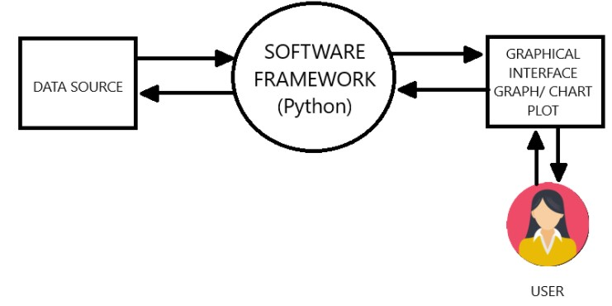

Level 0 DFD (Context Diagram)
[External Sources] → [IPL Analysis System] → [Stakeholders]
↓ ↓ ↓
Data Input Processing Insights Output

Level 1 DFD

[Data Sources] → [Data Collection] → [Data Cleaning] → [Database]
↓ ↓ ↓ ↓
CSV Files API Calls Transformation Storage

[Database] → [Analysis Module] → [Visualization] → [Reports]
↓ ↓ ↓ ↓
Queries ML Models Dashboards PDF/Excel

Flow Charts

START
↓
Initialize System
↓
Load IPL 2025 Data
↓
Preprocess Data
↓
Perform Statistical Analysis
↓
Run Machine Learning Models
↓
Generate Visualizations
↓
Create Reports
↓
END

Database Schema Design
Main Tables Structure
- Matches Table: Match details, results, venue
- Players Table: Player profiles, statistics
- Teams Table: Team information, performance metrics
- Venues Table: Stadium details, pitch conditions

User Interface Design
- Header: Project title and navigation
- Sidebar: Filter options and menu
- Main Area: Visualizations and insights
- Footer: Additional information and controls

Report Generation
- Automated PDF report generation
- Customizable report templates
- Scheduled reporting capabilitie

INTRODUCTION TO THE DATABASE USED
DATABASE SELECTION CRITERIA

Why MySQL?
MySQL was chosen as the primary database management system due to:
- Reliability: Proven track record in production environments
- Performance: Efficient handling of structured data
- Scalability: Ability to handle large datasets
- Community Support: Extensive documentation and resources
- Compatibility: Easy integration with Python and other tools
Database Structure
Main Tables Description
1. matches Table
sql
CREATE TABLE matches (
match_id INT PRIMARY KEY,
season YEAR,
match_date DATE,
venue_id INT,
team1_id INT,
team2_id INT,
toss_winner INT,
toss_decision ENUM('bat', 'field'),
winner INT,
win_by_runs INT,
win_by_wickets INT,
player_of_match INT,
FOREIGN KEY (venue_id) REFERENCES venues(venue_id),
FOREIGN KEY (team1_id) REFERENCES teams(team_id),
FOREIGN KEY (team2_id) REFERENCES teams(team_id)
);
2. players Table
sql
CREATE TABLE players (
player_id INT PRIMARY KEY,
player_name VARCHAR(100),
team_id INT,
role ENUM('batsman', 'bowler', 'all-rounder', 'wicket-keeper'),
batting_style ENUM('right-hand', 'left-hand'),
bowling_style VARCHAR(50),
country VARCHAR(50),
date_of_birth DATE,
FOREIGN KEY (team_id) REFERENCES teams(team_id)
);
3. teams Table
sql
CREATE TABLE teams (
team_id INT PRIMARY KEY,
team_name VARCHAR(50),
city VARCHAR(50),
home_venue_id INT,
captain_id INT,
coach_name VARCHAR(100),
established_year YEAR,
FOREIGN KEY (home_venue_id) REFERENCES venues(venue_id),
FOREIGN KEY (captain_id) REFERENCES players(player_id)
);
Data Collection and Integration
Data Sources Integration
- Primary Source: Official IPL website and APIs
- Secondary Sources: Cricket statistics websites
- Real-time Data: Live match feeds and updates
- Historical Data: IPL archives from 2008-2024
Data Cleaning Process
- Handling missing values
- Data normalization
- Outlier detection and treatment
- Data validation and verification
Database Operations
CRUD Operations
- Create: Adding new matches and player data
- Read: Querying for analysis and reporting
- Update: Modifying existing records
- Delete: Removing obsolete data
Advanced Queries
- Complex JOIN operations for multi-table analysis
- Aggregate functions for statistical calculations
- Stored procedures for routine operations
- Views for simplified data access

.

SOURCE CODE OF THE PROJECT

SOURCE CODE: -
import pandas as pd
import matplotlib.pyplot as plt

# Load Dataset
file_path = 'ipl_matches.csv'
df = pd.read_csv("ipl_matches.csv")

# Display all row and coloum Data Set
print('Display all rows of data Set')
print(df.head(30))

# Display of Coloum and data type of data set
print ('Display the info of data set')
print(df.info())

# Total matches
print('Total Matches:', len(df))
# Team wise wins
team_wins = df['Winner'].value_counts()
print('\nTeam Wins:\n', team_wins)
#display Most Team runs

team_runs = df.groupby('Team')['Team_Runs'].sum().sort_values(ascending=False)
print('\nTeam Wins:\n', team_runs)
# Display top bowlers & wicket Taker

bowler_stats=df.groupby('Best_Bowler')['Wickets_Taken'].sum().sort_values(ascending=False)
top_bowlers = bowler_stats.head()
print('Top Wikect taker :',top_bowlers)

# Display top Batters & most runs
Runs_stats =df.groupby('Top_Scorer')['Top_Score'].sum().sort_values(ascending=False)
top_baters = Runs_stats.head()
print('Most Runs :',top_baters)

# Check missing values in each column
missing_values = df.isnull().sum()
print(" Missing Values in each column:\n", missing_values)

# Example: Unique teams
unique_teams = df['Team'].unique()
print("\n Unique Teams:", unique_teams)

# Example: Unique venues
unique_venues = df['Venue'].unique()
print("\n Unique Venues:", unique_venues)

# Example: Unique top scorers
unique_scorers = df['Top_Scorer'].unique()
print("\n Unique Top Scorers:", unique_scorers)

# ------------------- 1 Most Runs by Team Pie Chart ------------------
plt.figure(figsize=(6,6))
team_runs.plot(kind='pie',autopct='%1.1f%%', startangle=140)
plt.title("Total Runs by Team")
plt.ylabel('')
plt.show()

# ------------------- 2 Most Wins by Team Pie chart ------------------
plt.figure(figsize=(6,6))
team_wins.plot(kind='pie', autopct='%1.1f%%', startangle=140)
plt.title("Most Wins by Teams")
plt.ylabel('')
plt.show()

#------------------- 3 Most Wickets by Bowlers -------------------
plt.figure(figsize=(8,5))
plt.bar(bowler_stats.index,bowler_stats.values, color='skyblue')
plt.title("Most Wickets by Bowlers")
plt.xlabel("Bowlers")
plt.ylabel("Wickets Taken")
plt.xticks(rotation=45, ha='right')
# Show numbers on top of bars
for i, v in enumerate(bowler_stats.values):
plt.text(i, v+0.1, str(v), ha='center')
plt.tight_layout()
plt.show()

# ------------------- 4 Most Runs by Players Bar Graph -------------------
plt.figure(figsize=(10,5))
plt.bar(Runs_stats.index,Runs_stats.values, color='purple')
plt.title("Most Runs by Players")
plt.xlabel("Players")
plt.ylabel("Total Runs")
plt.xticks(rotation=45, ha='right')
for i, v in enumerate(Runs_stats.values):
plt.text(i, v+0.1, str(v), ha='center')
plt.tight_layout()
plt.show()

# ------------------- 5 Most Wins by Team Bar Graph ------------------
plt.figure(figsize=(8,5))
plt.bar(team_wins.index, team_wins.values, color='green')
plt.title("Most Wins by Team")
plt.xlabel("Teams")
plt.ylabel("Number of Wins")
plt.xticks(rotation=45,ha='right')
for i,v in enumerate(team_wins.values):
plt.text(i, v+0.1,str(v),ha='center')
plt.tight_layout()
plt.show()

# ------------------- 6 Most Runs by Players Bar Graph ------------------
plt.figure(figsize=(10,5))
plt.bar(Runs_stats.index,Runs_stats.values, color='purple')
plt.title("Most Runs by Players")
plt.xlabel("Players")
plt.ylabel("Total Runs")
plt.xticks(rotation=45, ha='right')
for i, v in enumerate(Runs_stats.values):
plt.text(i, v+0.1, str(v), ha='center')
plt.tight_layout()
plt.show()

# ------------------- Plotting on a Single Page Bar Graph ------------------

fig, axes = plt.subplots(2, 2, figsize=(16, 12))
fig.suptitle("IPL 2025 Analysis Dashboard", fontsize=18)

# 1️ Most Wickets by Bowlers
axes[0, 0].bar(bowler_stats.index, bowler_stats.values, color='skyblue')
axes[0, 0].set_title("Most Wickets by Bowlers")
axes[0, 0].set_ylabel("Wickets Taken")
axes[0, 0].tick_params(axis='x', rotation=45)
for i, v in enumerate(bowler_stats.values):
axes[0, 0].text(i, v + 0.1, str(v), ha='center')

# 2️ Most Runs by Team
axes[0, 1].bar(team_runs.index, team_runs.values, color='orange')
axes[0, 1].set_title("Most Runs by Team")
axes[0, 1].set_ylabel("Total Runs")
axes[0, 1].tick_params(axis='x', rotation=45)
for i, v in enumerate(team_runs.values):
axes[0, 1].text(i, v + 0.1, str(v), ha='center')

# 3️ Most Wins by Team
axes[1, 0].bar(team_wins.index, team_wins.values, color='green')
axes[1, 0].set_title("Most Wins by Team")
axes[1, 0].set_ylabel("Number of Wins")
axes[1, 0].tick_params(axis='x', rotation=45)
for i, v in enumerate(team_wins.values):
axes[1, 0].text(i, v + 0.1, str(v), ha='center')

# 4️ Most Runs by Players
axes[1, 1].bar(Runs_stats.index, Runs_stats.values, color='purple')
axes[1, 1].set_title("Most Runs by Players")
axes[1, 1].set_ylabel("Total Runs")
axes[1, 1].tick_params(axis='x', rotation=45)
for i, v in enumerate(Runs_stats.values):
axes[1, 1].text(i, v + 0.1, str(v), ha='center')

# Adjust layout and show
plt.tight_layout(rect=[0, 0, 1, 0.95])
plt.show()

SCREENSHOT OF THE PROJECT

OUTPUT: -
Dataset:
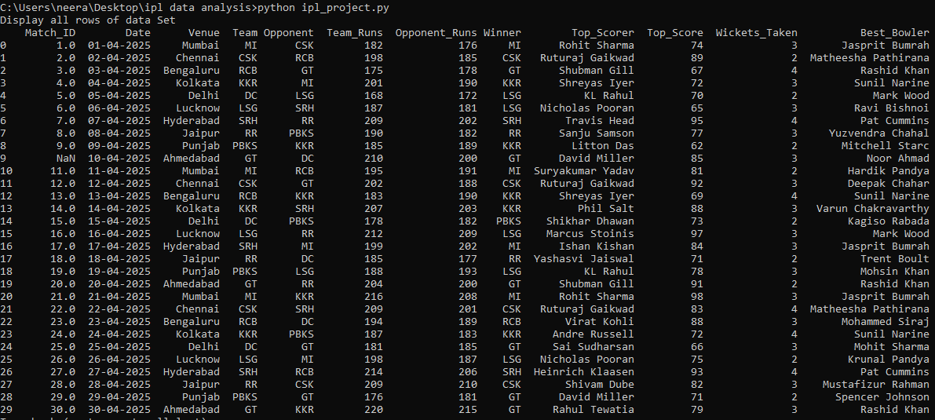

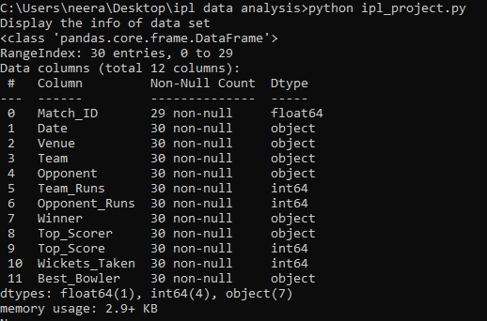

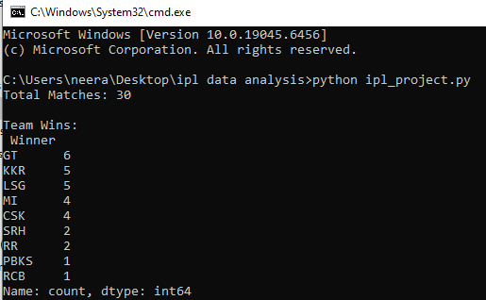

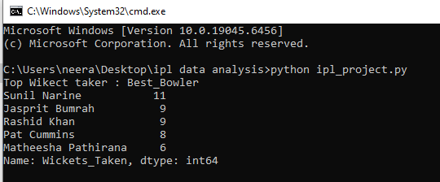

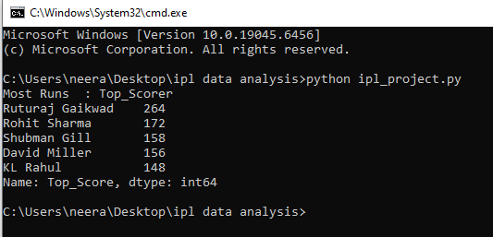

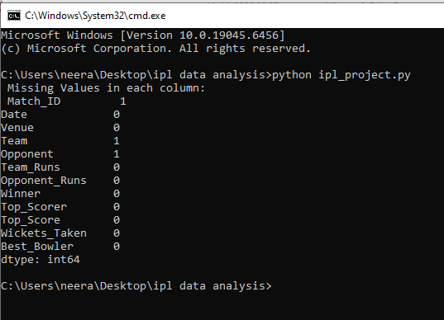

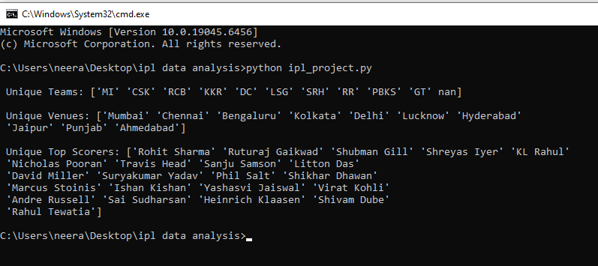
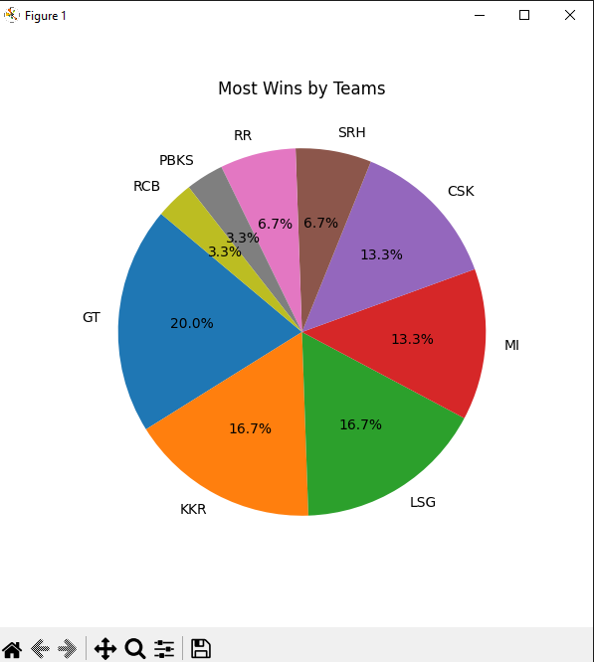
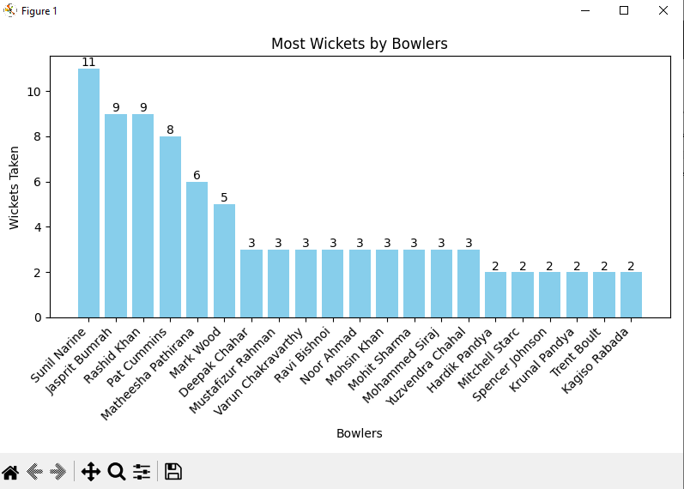
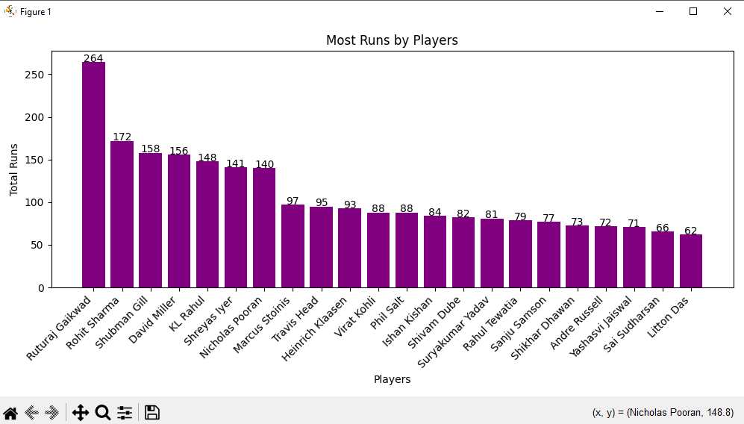
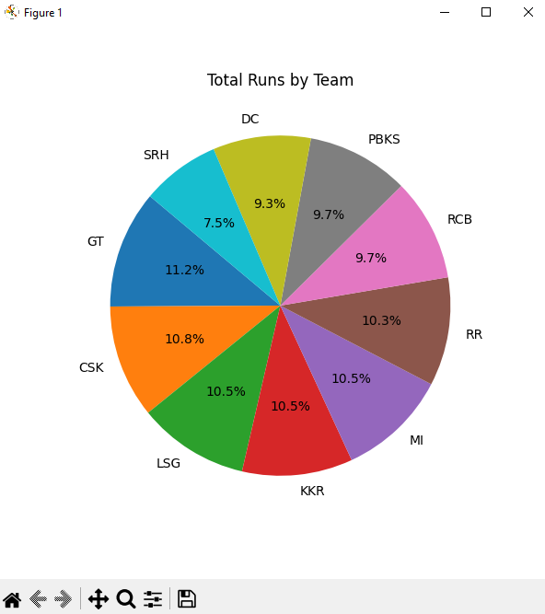
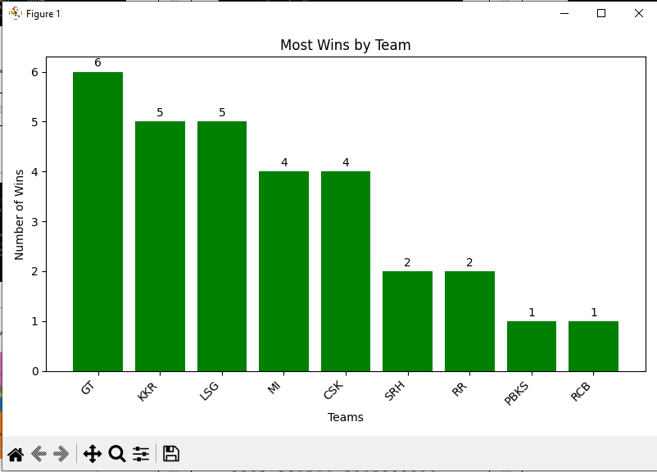

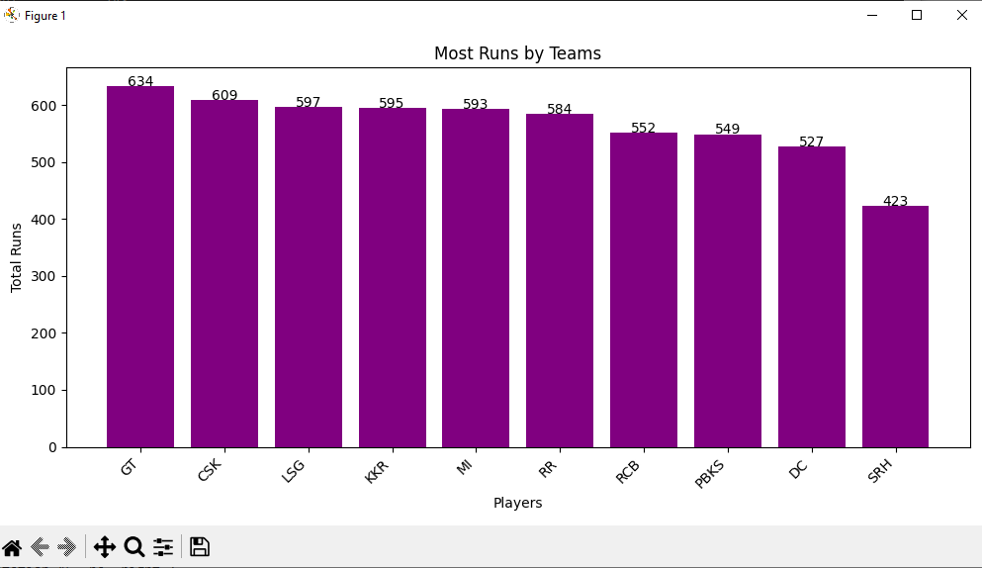
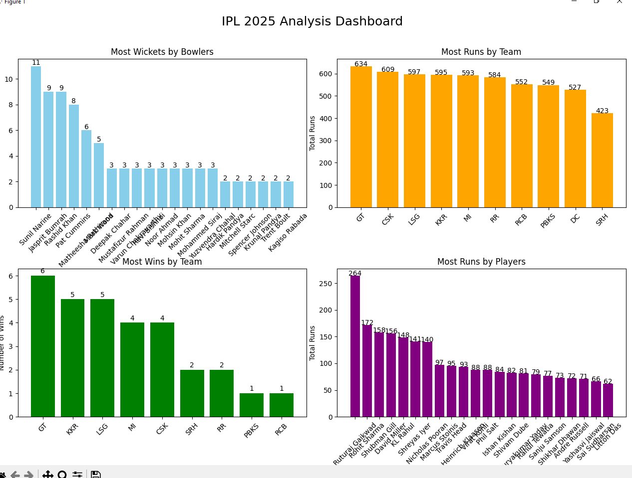

FUTURE SCOPE OF THE PROJECT

TECHNICAL ENHANCEMENTS

Advanced AI Integration
- Deep Learning Models: Implement LSTM networks for time-series prediction of player form and match outcomes
- Computer Vision: Integrate ball-tracking and player movement analysis using camera feeds
- Natural Language Processing: Analyze social media sentiment and commentary for additional insights
- Reinforcement Learning: Develop AI agents that can suggest optimal strategies in real-time
Real-time Analytics Expansion
- Live Streaming Integration: Direct integration with broadcast feeds for instant analysis
- IoT Sensor Data: Incorporate data from smart stadiums and wearable player technology
- Mobile Application: Develop companion mobile app for on-the-go insights
- Voice Assistants: Create voice-enabled analytics through Alexa/Google Assistant
Feature Additions
Enhanced Predictive Models
- Injury Prediction: Machine learning models to predict player injuries based on workload and biomechanics
- Auction Value Prediction: AI-powered player valuation for IPL auctions
- Career Trajectory Forecasting: Long-term player development predictions
- Team Chemistry Analysis: Social network analysis of player interactions and team dynamics
Interactive Features
- Virtual Reality Integration: Immersive VR experiences for match analysis
- Fantasy League Integration: Direct connection with fantasy cricket platforms
- Betting Market Analysis: Legal and responsible betting market insights
- Fan Engagement Tools: Interactive polls, predictions, and social features
Business Applications
Commercial Expansion
- Broadcast Enhancement: Provide real-time analytics to broadcasters for enhanced commentary
- Sponsorship Analytics: Help brands measure ROI and optimize sponsorship strategies
- Merchandising Insights: Sales prediction and inventory management for team merchandise
- Ticket Pricing Optimization: Dynamic pricing models based on demand forecasting
Global Scalability
- Multi-League Support: Expand analysis to include other T20 leagues worldwide
- International Cricket: Adapt system for ODI and Test cricket analysis
- Women's Cricket: Specialized analysis for women's IPL and international matches
- Grassroots Development: Tools for amateur and youth cricket development
Research and Development
Academic Applications
- Sports Science Research: Collaboration with sports scientists for performance optimization
- Statistical Research: Advanced cricket analytics research papers and publications
- Talent Identification: Scientific approaches to talent spotting and development
- Training Optimization: Data-driven training regimen recommendations
Technology Stack Upgrades
- Blockchain Integration: Secure and transparent player contracts and transactions
- Edge Computing: Real-time processing at stadium locations for reduced latency
- 5G Integration: Leverage high-speed networks for enhanced mobile experiences
- Quantum Computing: Explore quantum algorithms for complex optimization problems

BIBLIOGRAPHY

Online Resources
- Official IPL Website and Statistics
  - https://www.iplt20.com
- ESPN Cricinfo API Documentation
  - https://www.espncricinfo.com/ci/content/api/
- Cricket Australia Sports Science Research
  - https://www.cricketaustralia.com.au/sports-science

REFERENCES

  - www.tuturialspoint.com
  - www.geeksforgeeks.org
  - www.Keggle.com
  - ChatGPT

